**Docker**

**Docker is a centralized platform for packaging, deploying, and running applications**. Before Docker, many users face the problem that a particular code is running in the developer's system but not in the user's system. So, the main reason to develop docker is to help developers to develop applications easily, ship them into containers, and can be deployed anywhere.

Docker is an open-source centralized platform designed to create, deploy, and run applications. Docker uses container on the host's operating system to run applications. It allows applications to use the same Linux kernel as a system on the host computer, rather than creating a whole virtual operating system.

**Maintainability.**

### Docker Containers

Docker containers are the lightweight alternatives of the virtual machine. It allows developers to package up the application with all its libraries and dependencies, and ship it as a single package. The advantage of using a docker container is that you don't need to allocate any RAM and disk space for the applications. It automatically generates storage and space according to the application requirement.

(or)

container are complete **isolated environment , they can have there own processes or services there own network interfaces**.except they all share the same OS kernel.Docker utili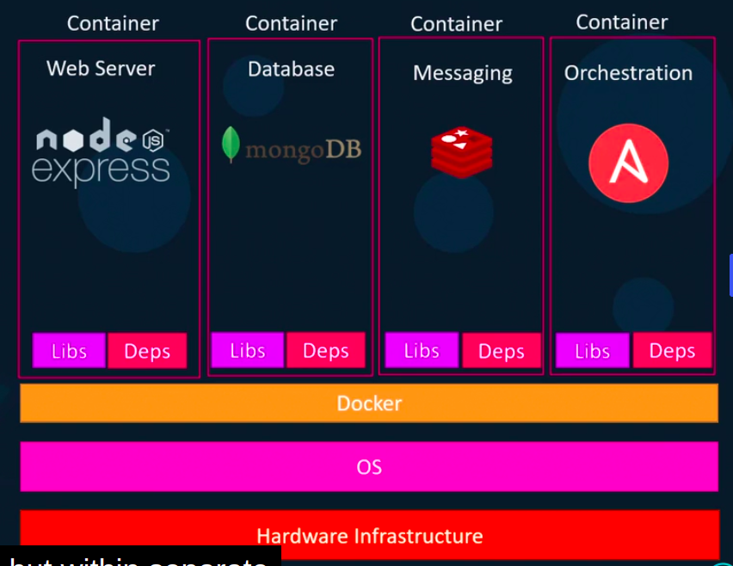zes LXC containers. **Containers are portable.**

### Containers Vs. Virtual Machine

|  |  |
| --- | --- |
| Containers | Virtual Machine |
| Integration in a container is faster and cheap. | Integration in virtual is slow and costly. |
| No wastage of memory. | Wastage of memory. |
| It uses the same kernel, but different distribution. | It uses multiple independent operating systems. |

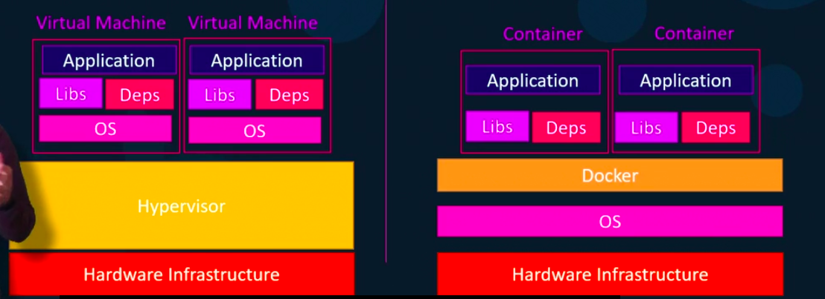

**Docker images**: image is a template for creating an environment of your choice (like databases etc) . image is used to create a one or more containers.

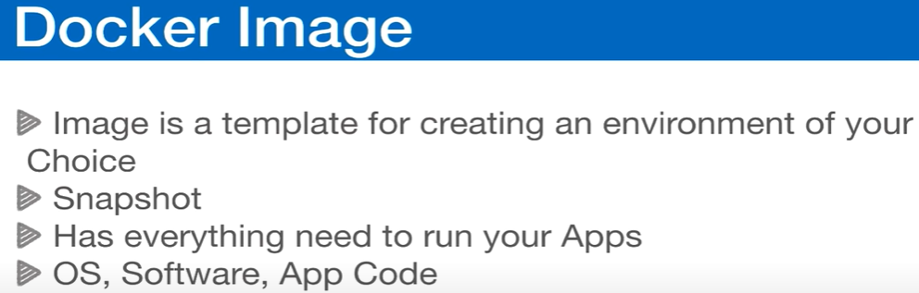

Containers are running instances of images that are isolated and have there own environments and set of processes.

Or

Images are used to store and ship applications. An image can be used on its own to build a container or customized to add additional elements to extend the current configuration.

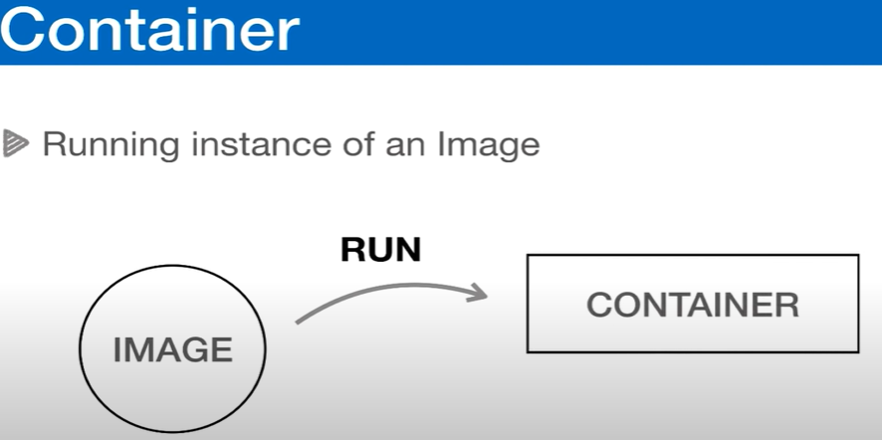

**Container**: container is running an instance of image.

**Docker image commands:**

**docker pull nginx( nginx is image)** => to pull an image from the docker hub.

**docker images** => to see list of images.

**Docker Container Commands:**

**docker run nginx(image):latest=>** run the instance nginx of application to create container.

**docker run -d nginx(image):latest=>** run the instance nginx of application to create container in detach mode( detachedmode is nothing but running the container in background ).

**Docker container ls** => print app the running containers.

OR

**Docker ps** => print all running containers.

**Docker ps -a** => print all available containers.

**Docker stop container_ID** => stop the container by ID .

**Docker rm -f container_ID or container_name** :remove the container by force without stop

**Exposing ports:**

**Docker run -d -p 8080:80 nginx:latest =>** its will run the nginx image by creating container in a detached mode by mapping localhost 8080 port to container port 80.

**Exposing multiple ports:**

**Docker run -d -p 8080:80 -p 3000:80 nginx:latest =>** its will run the nginx image by creating container in a detached mode by mapping multiple ports localhost 8080 port to container port 80 and localhost 3000 port to 80.

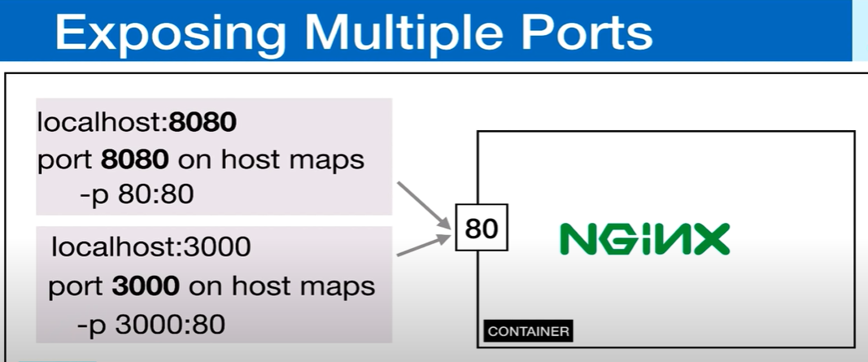

**Managing Containers:**

**Docker stop CotainerName or container_ID**. => to stop container.

**Docker start** **CotainerName or container_ID**=> to start container .

**Docker rm CotainerName or container_ID** => to remove (Delete) the container.

**Docker rmi nginx (IMAGE_NAME)=>** to remove (Delete)the image (first remove (Delete) all containers.)

**Delete (rm command ) all available and quite containers but is will not delete the running containers.**

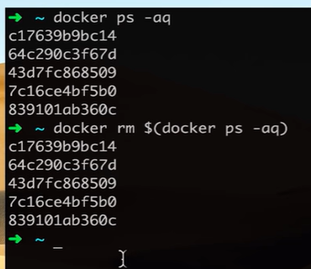

**( rm )command It will not delete the running containers. Use -f force to delete**

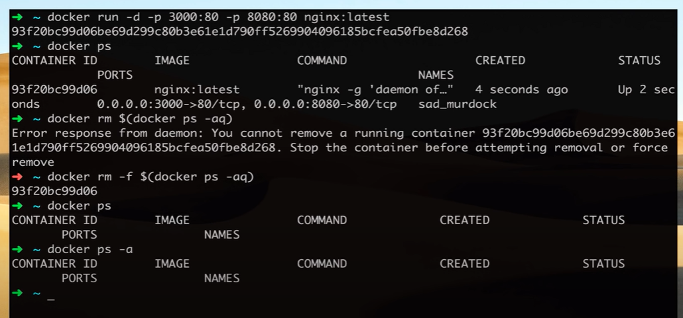

**Naming Containers:**

**Docker run - -name website -d -p 8080:80 -p 3000:80 nginx:latest =>** naming website to

**Docker Volumes:**

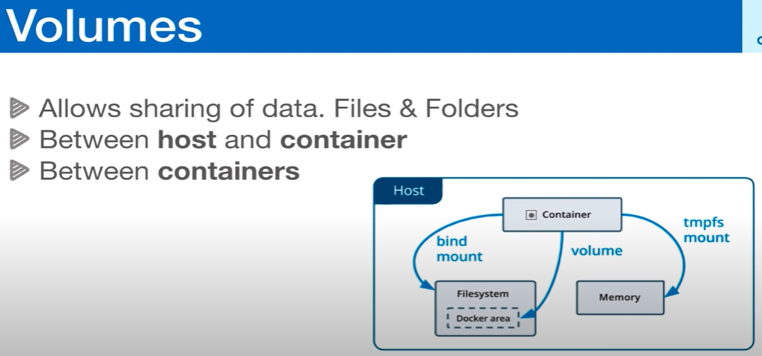

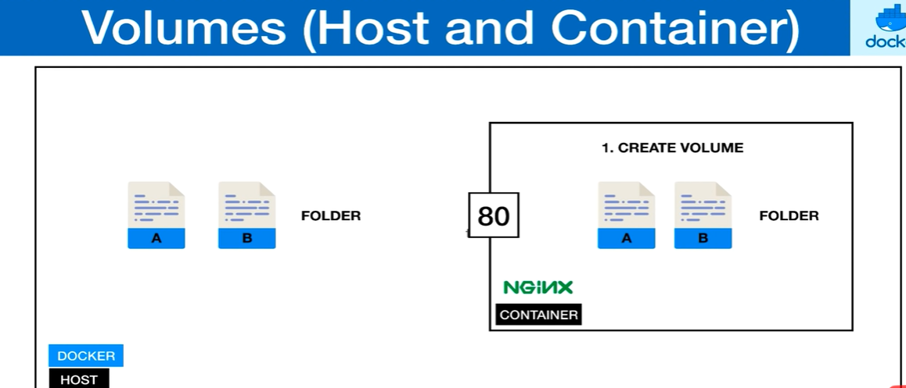

$ docker run --name some-nginx -v /some/content:/usr/share/nginx/html:ro -d nginx

Name some-nginx -V Volume source : destination :read only mode .

**Volumes Between Host and Containers:**

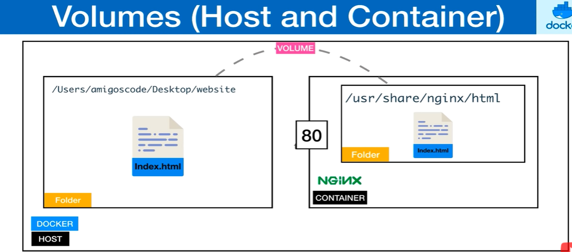

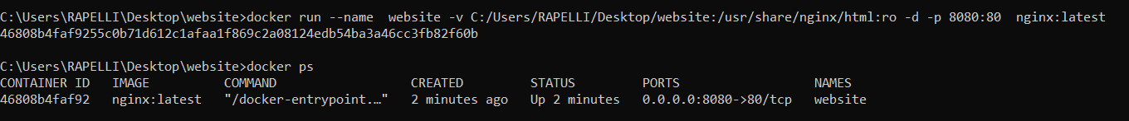

**Output**:



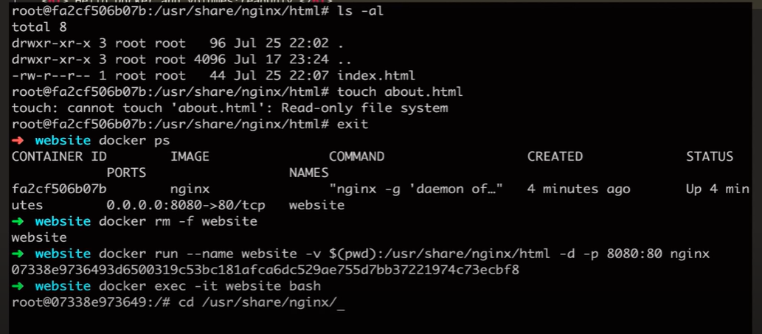

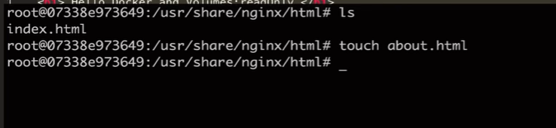

**Customise website:**

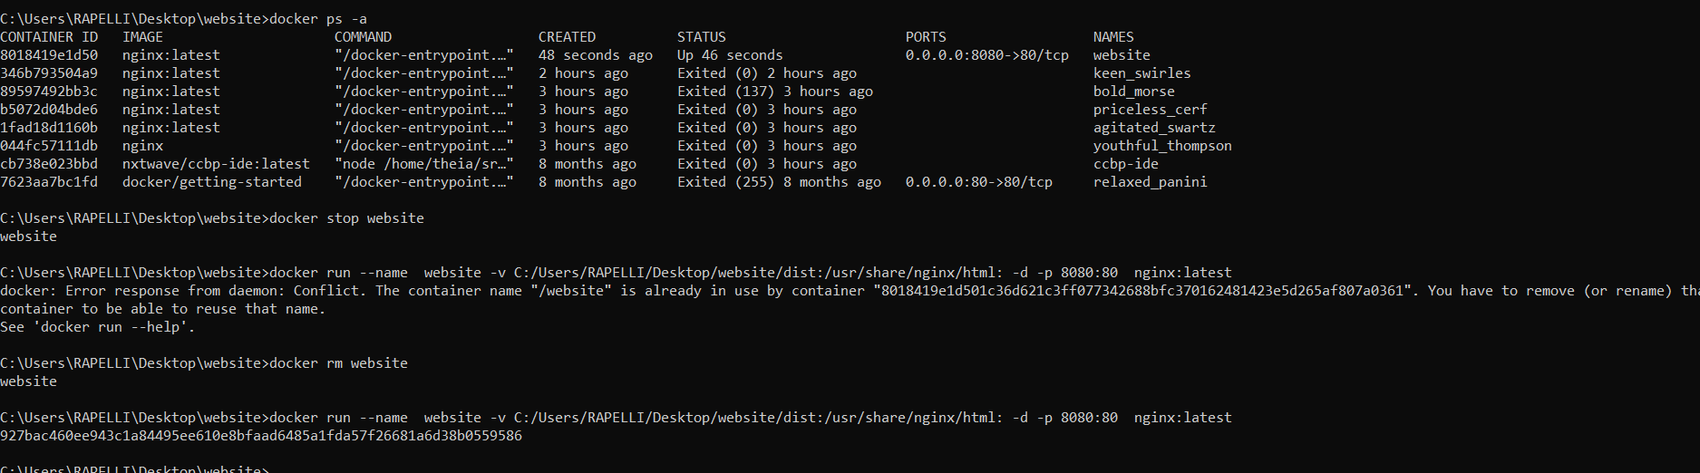

**Deployed the application on the localhost**

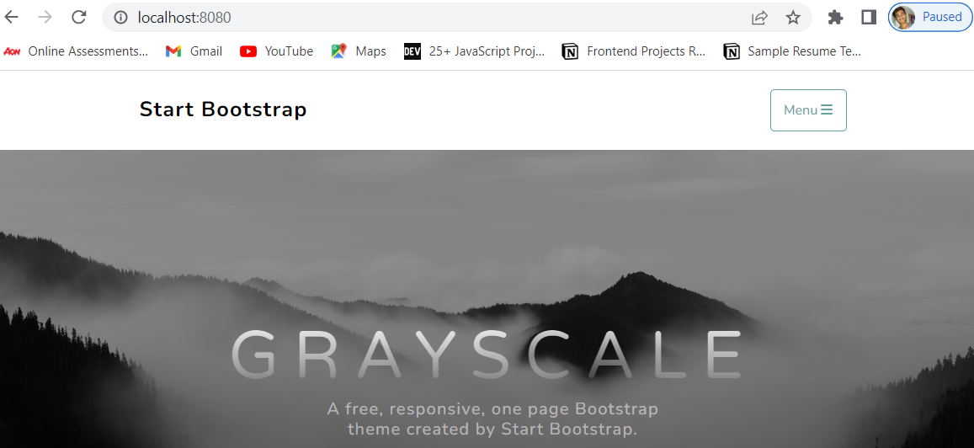

**Sharing Volumes Between Containers:**

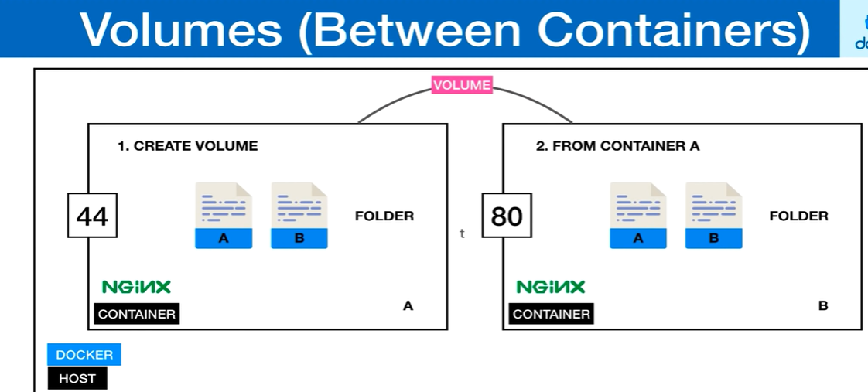

**To share volumes between containers we need to use two different ports and copy one volume to another volume.**

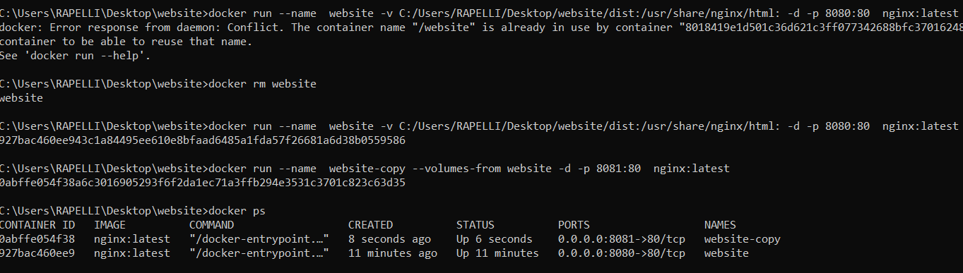

**Dockerfile:**

Docker can build images automatically by reading the instructions from a Dockerfile. A Dockerfile is a text document that contains all the commands a user could call on the command line to assemble an image. This page describes the commands you can use in a Dockerfile.

It helps us to build our own images by writing Dockerfile as mentioned below.

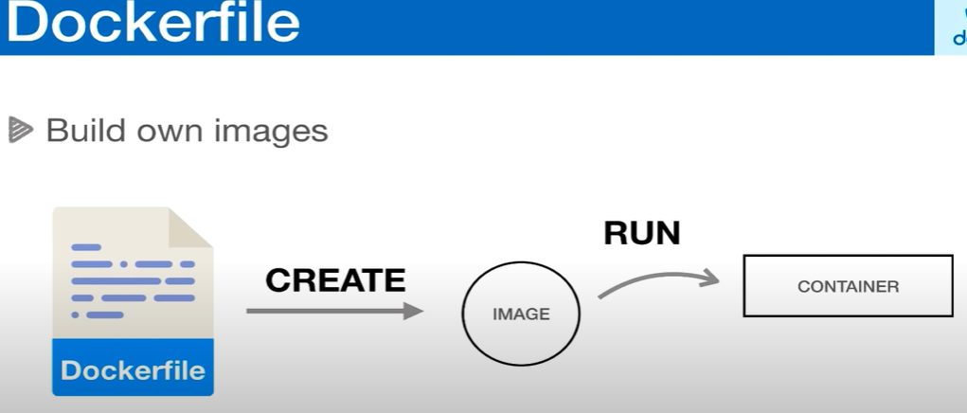

**Example:**

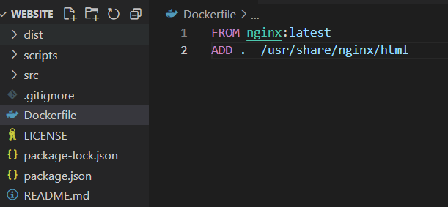

Dockerfile should be inside the current dir, we can also pass the environment variables.

Command to build:

Docker build - - tag user-service-api:latest .

**OR**

**Docker build –tag –name user-service-api -d -p 8080:80 user-service-api:latest .**

**Caching and Layers**

**Docker file Ignore:**

Add the .dockerignore file and add the files, folders to ignore while building image.

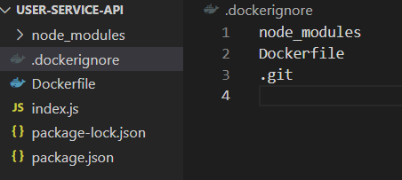

After that build the image and create a container and run it.

**Docker build –tag –name user-service-api -d -p 8080:80 user-service-api:latest .**

Start container again .

**Caching and Layers:**

**Reducing Image Size:**

**-Linux Alpine**

**- Pulling Aline Docker Images**

**- Switching to Alpine**

**- Linux Alpine : small , simple, secure**

* Alpine Linux is an independent, non-commercial, general purpose Linux distribution designed for power users who appreciate security, simplicity and resource efficiency.
* Alpine Linux is built around musl libc and busybox. This makes it small and very resource efficient. A container requires no more than 8 MB and a minimal installation to disk requires around 130 MB of storage.

**- Pulling Aline Docker Images:**

**docker pull node:alpine =>** it will pull the node image from docker hub of less size due to alpine.

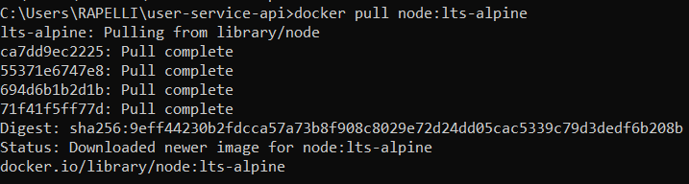

**Or**

**docker pull node:alpine:**

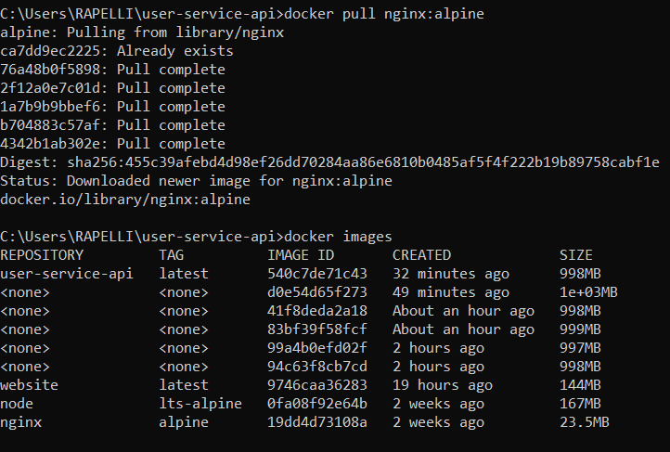

**Tags and Versioning :**



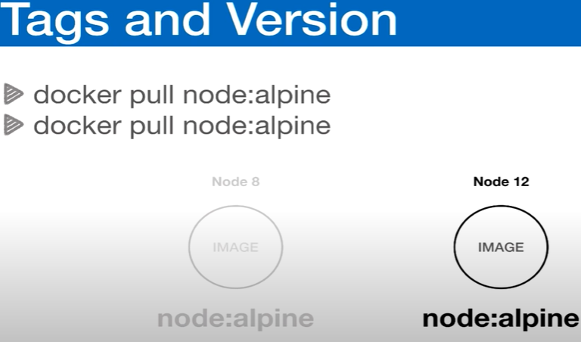

**- Using Tags**

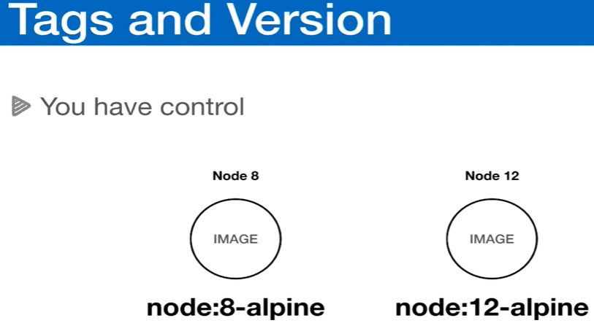

**- Running Containers Using Tags :**

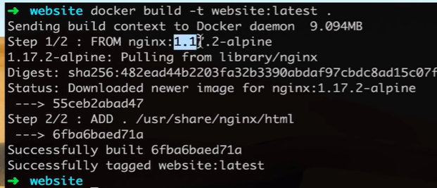

- Tagging Override : when we don’t mention the proper tags the images will override example:

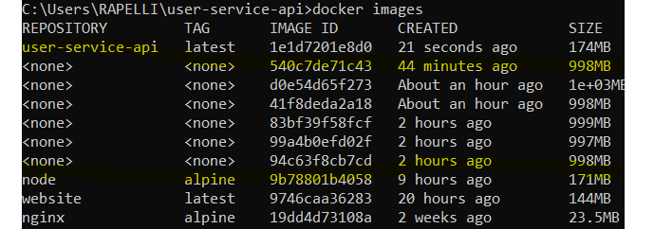

**- Tagging Images :**

Command => **docker tag user-service-api:latest user-service-api:1**

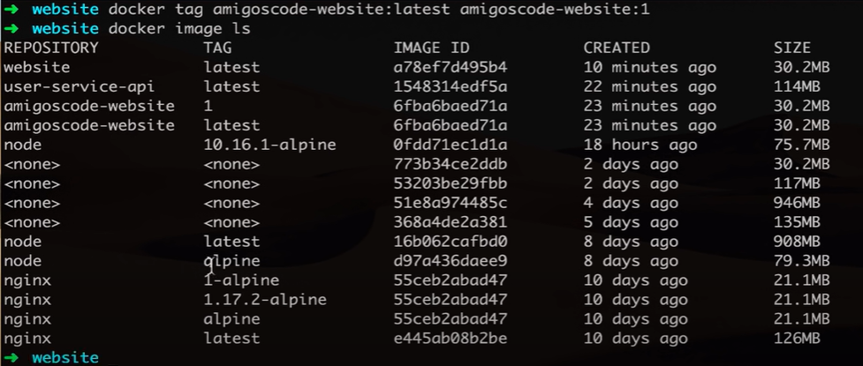

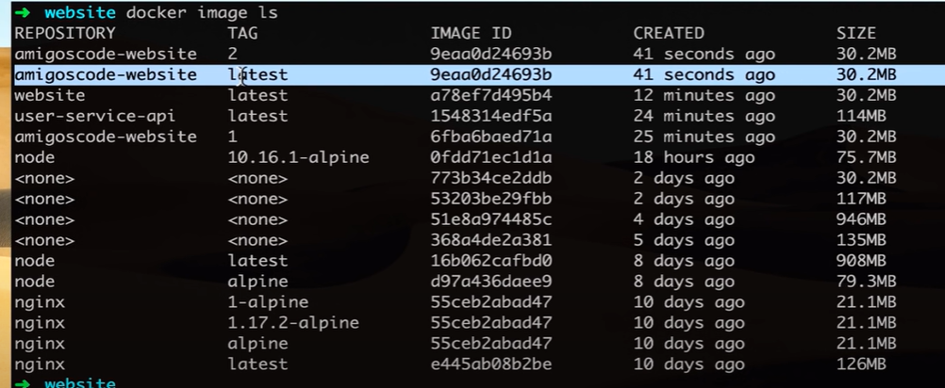

**- Running Container Using Tags:**

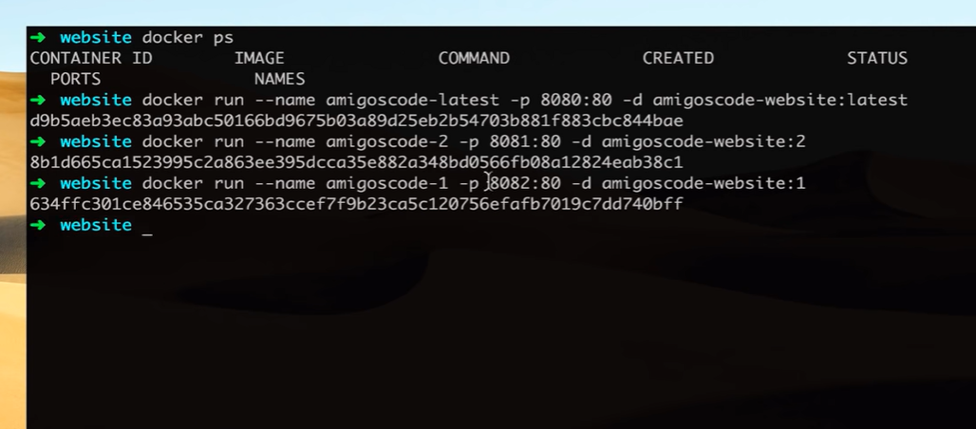

**Docker Registries:**

Docker registries highly scalable server side application that stores and lets you distribute docker images .

* Its also used for CD/CI pipeline .
* Run you application .

We use push command to push the image from localhost to server (docker hub)

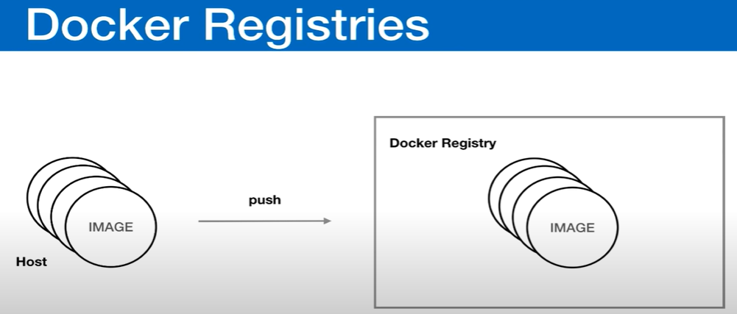

**The registers are of two types**

* Public
* Private
* 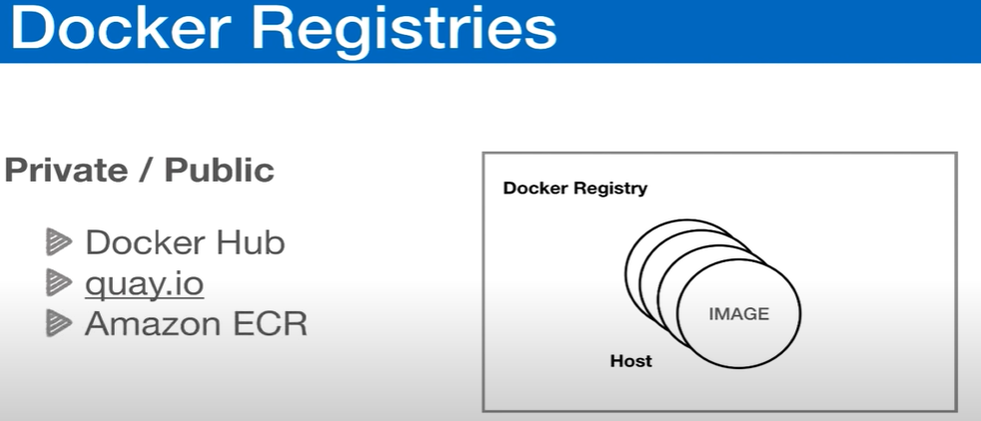

**Pushing images to docker Hub:**

Command to push:



**Pulling images from registry (Docker Hub):**

**Command to pull:**

Docker pull amigoscode / website: latest

**Debugging Containers:**

* Docker Inspect
* Docker Logs
* Docker exec

**Inspect Container:**

**docker inspect Container_Name or Container_ID**: gives the complete info of the container .

Example : Its give much more info then the below one Example.

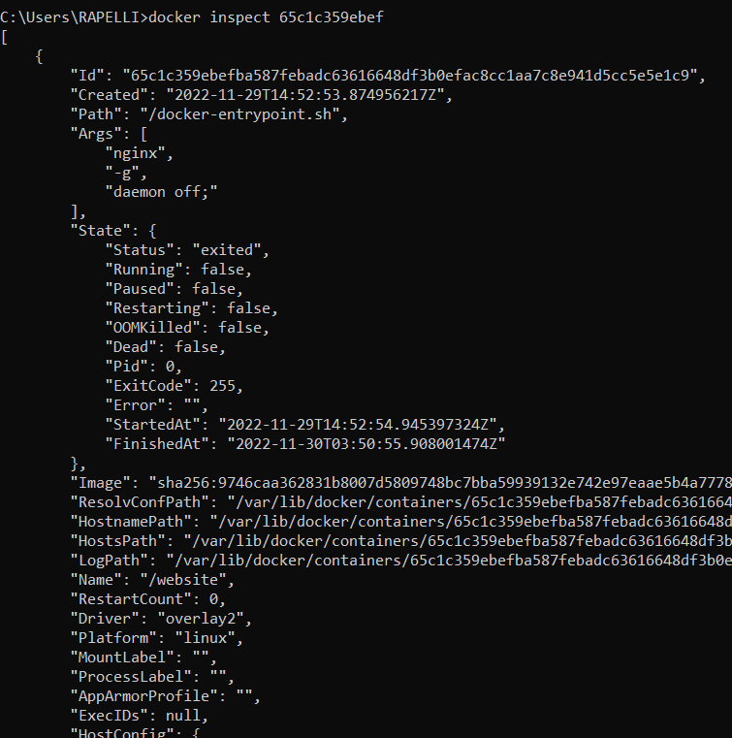

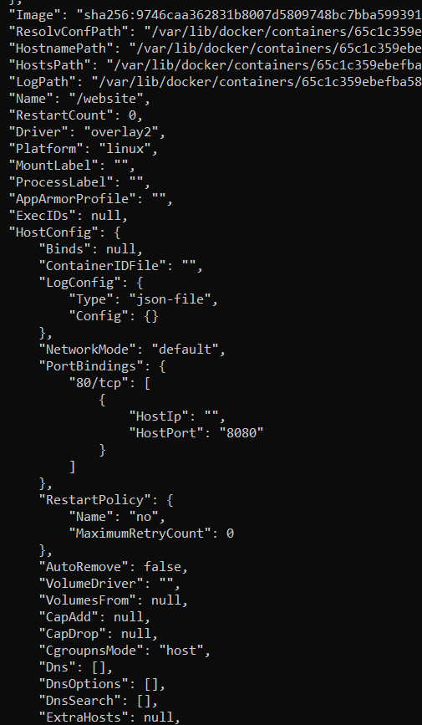

**Container Logs:**

**docker logs container_name :**

**docker logs -f container_name or container_ID:**

**example:**

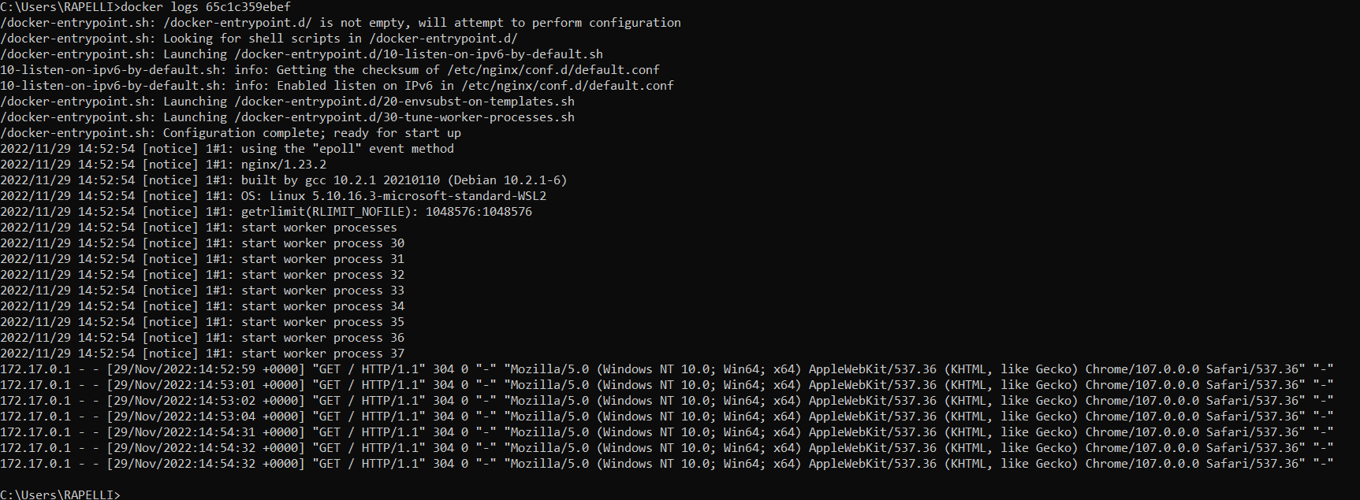

**Example:**

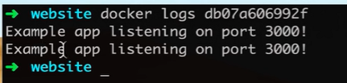

**Docker exec:**

**To jump into the container see how its working**

**Command : docker exec -it container_Name or container_ID /bin/bash**

**or**

**docker exec -it container_Name or container_ID /bin/sh**

this commands helps us go inside the container

**command :ls -al** => list all the folders in the working directory

when we go back using cd .. we can see the linux system which helps us to run the container on linux operating system.

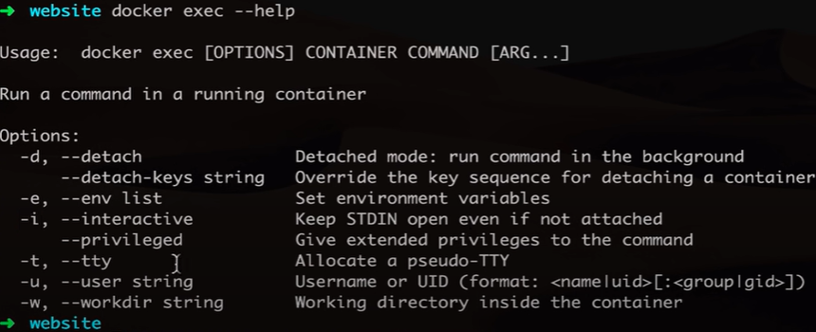

**Docker commands:**

docker run nginx=> run the instance nginx of application.

Docker ps => print all running containers.

Docker ps -a => shows all previously and now running container.

Docker stop ContainerName. => to stop container.

Docker rm CotainerName => to remove the container.

Docker images => list of images.

Docker rmi nginx (IMAGE_NAME)=> to remove the image (first remove all containers.)

docker pull nginx( nginx is image) => to pull an image from the docker hub

docker run container sleep 5 => sleep for 5 sec.

Docker exec distract_mcclintock cat /*etc*/hosts => executes

Run – Attach and detach :

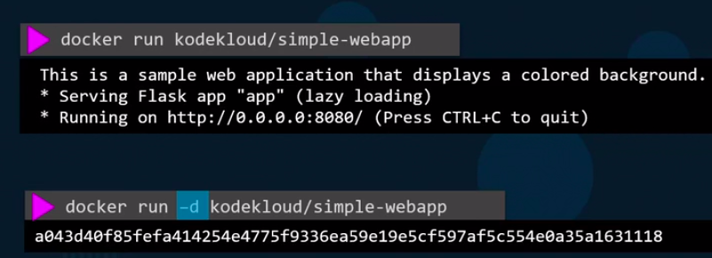

docker attach IDNUM(a04f9)

docker attach

DEMO:

sudo docker run -it centos bash

cat /*etc/*\*release*

exit

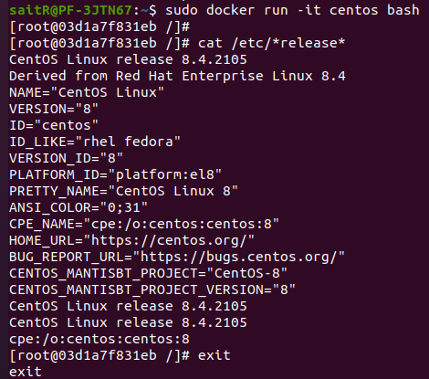

**docker sleep :**

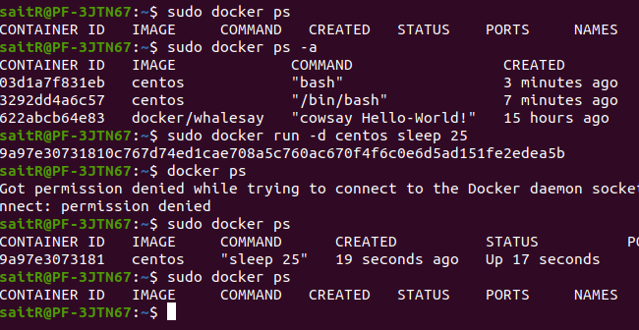

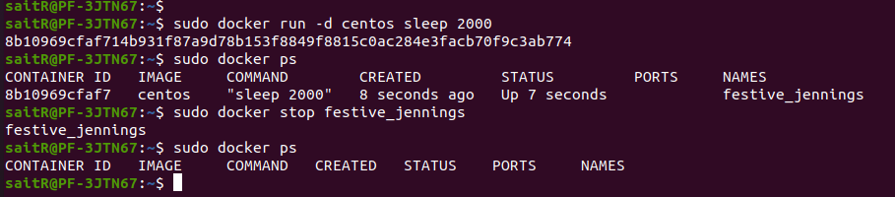

**remove container:**

remove by container Name:

remove by container ID:

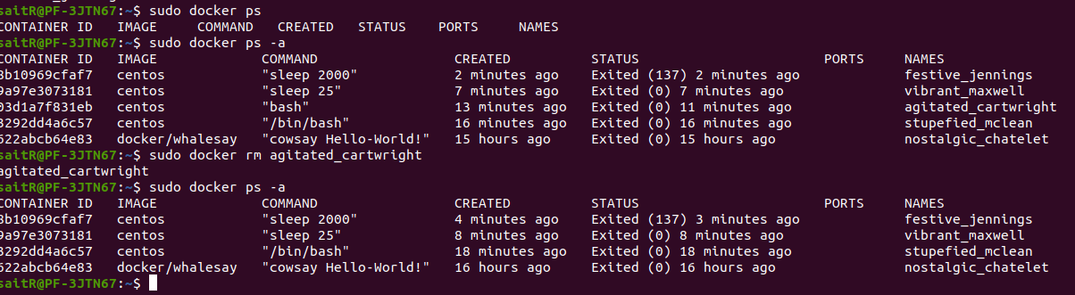

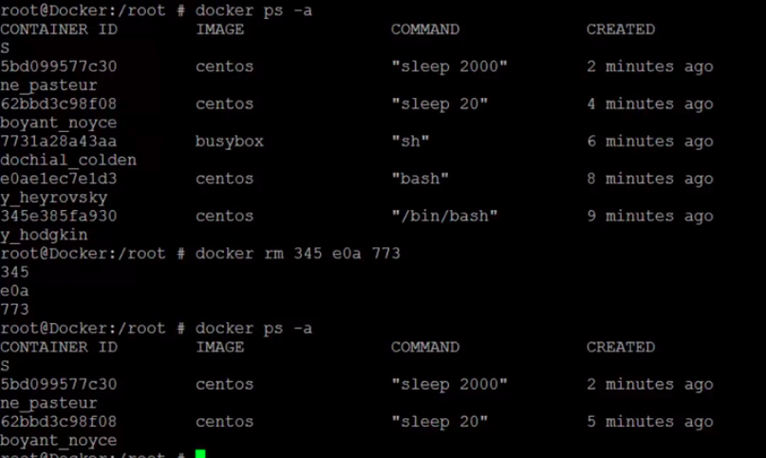

**Docker Images:**

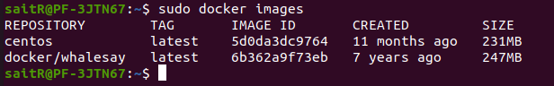

**remove docker images:**

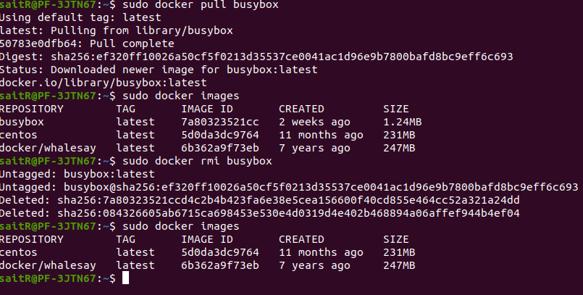

**docker Exec: exec command execute on a running container.**

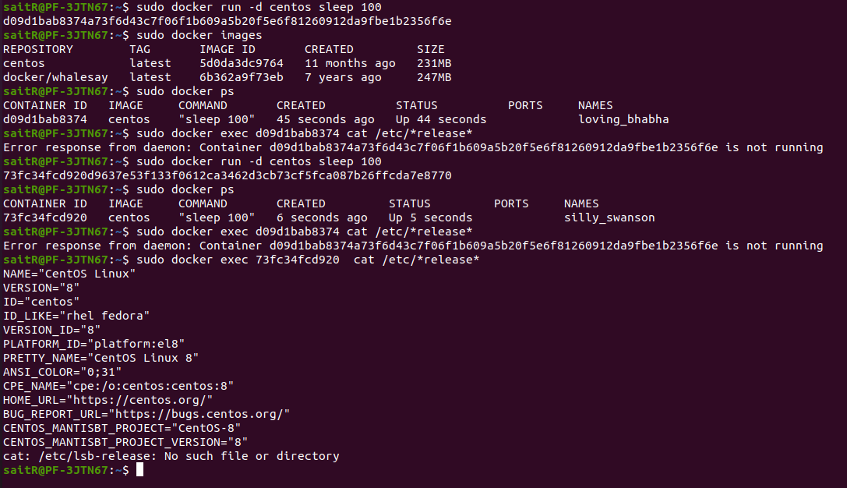

**To delete all containers and images:**

docker rmi <IMAGE:TAG>

Stop and delete all the containers being used by images.  
Then run the command to delete all the available images: docker rmi $(docker images -aq)

**run tag:**

docker run redis => pulls the latest version of the redis.

Docker run redis:4.0.4 => pulls the version mentioned

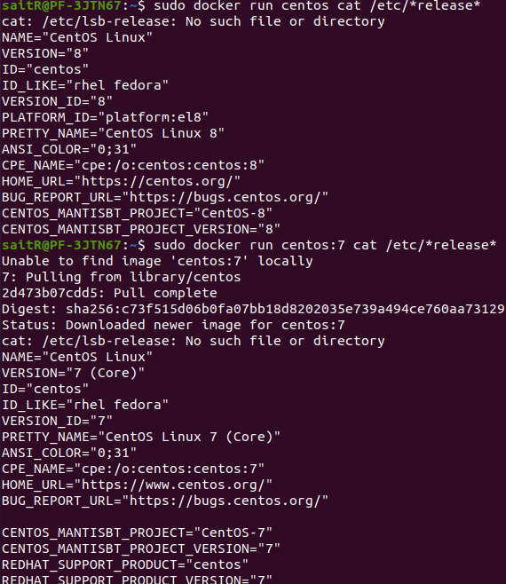

Run – STDIN:

**Run -PORT mapping:**

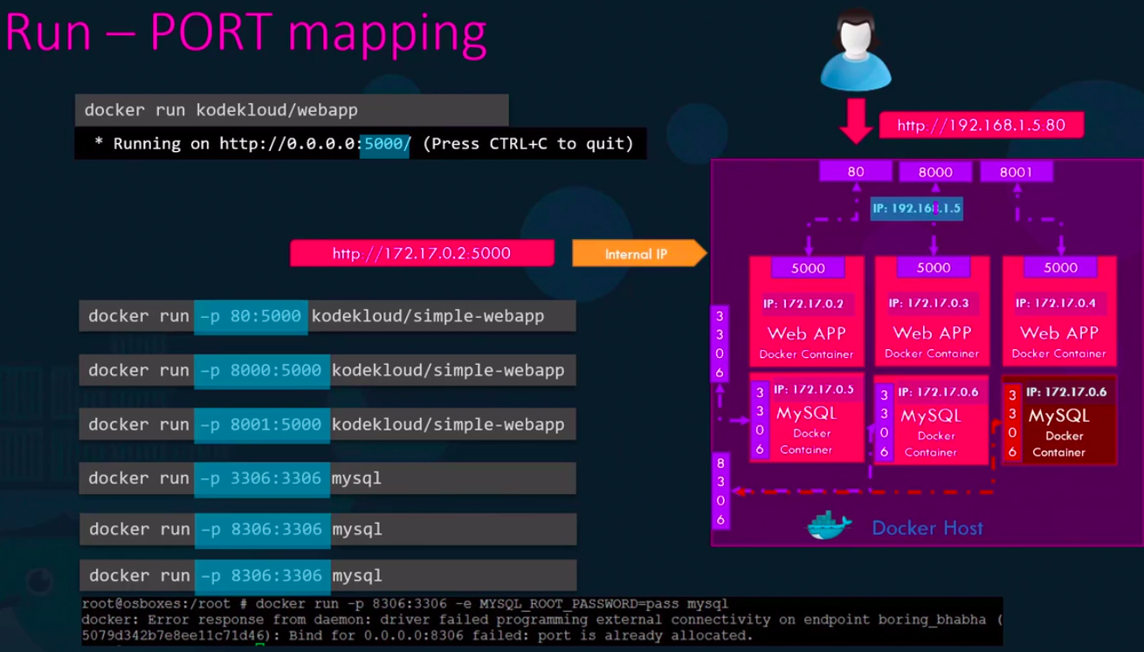

**Run Volume Mapping:**

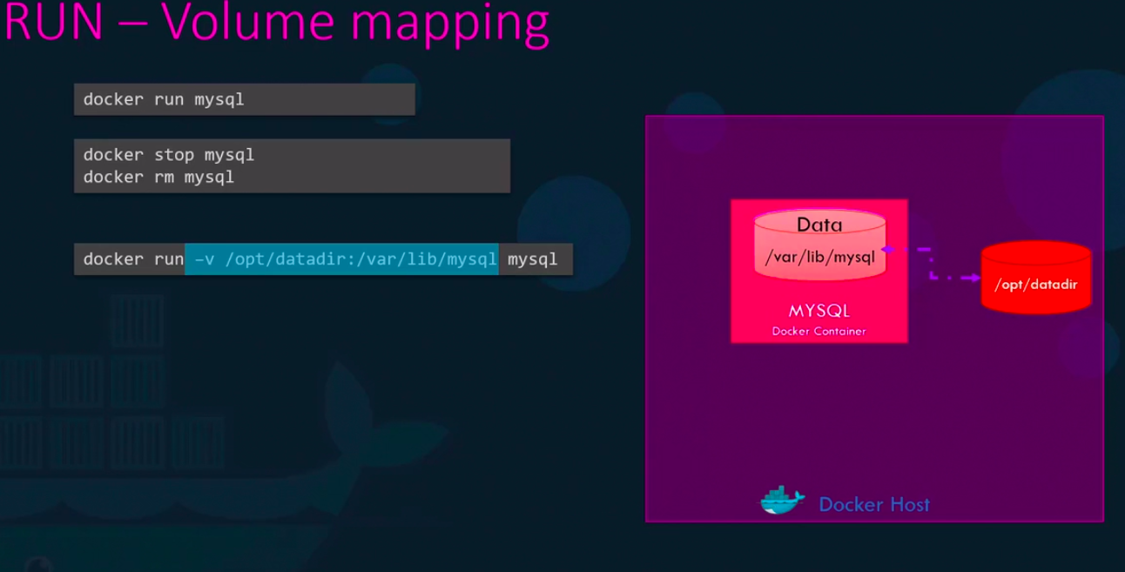

**Inspect Container:**

docker inspect Container_Name:

**Container Logs:**

docker logs container_name

**Docker Images:**

**$ docker build -t webapp-color => create a docker image.**

**commands:**

apt-get update

apt-get install -y python3

apt-get install python3-pip

pip install flask

create a copy application code to */opt/app.py*

FLASK_APP=/opt/app.py flask run --host=0.0.0.0

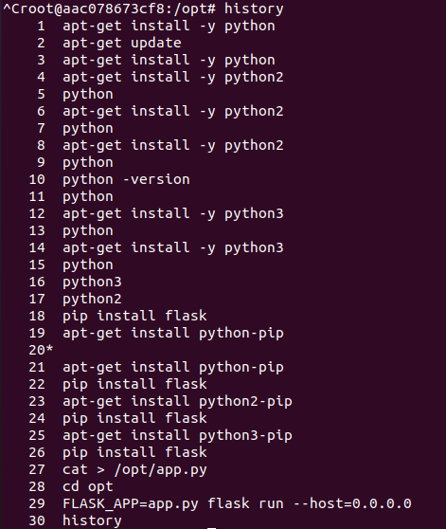

**Environment variables:**

in the dockerfile we can set the env variables,

color =os.environ.get(‘App-COLOR’);

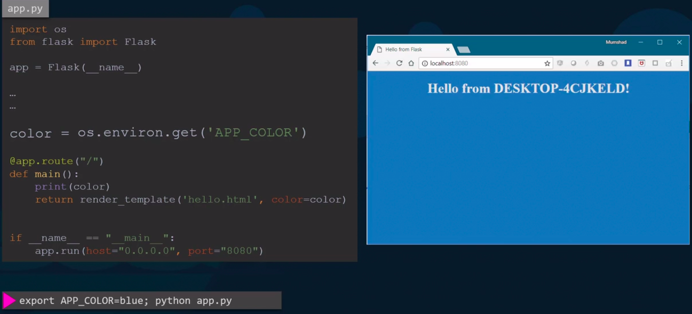

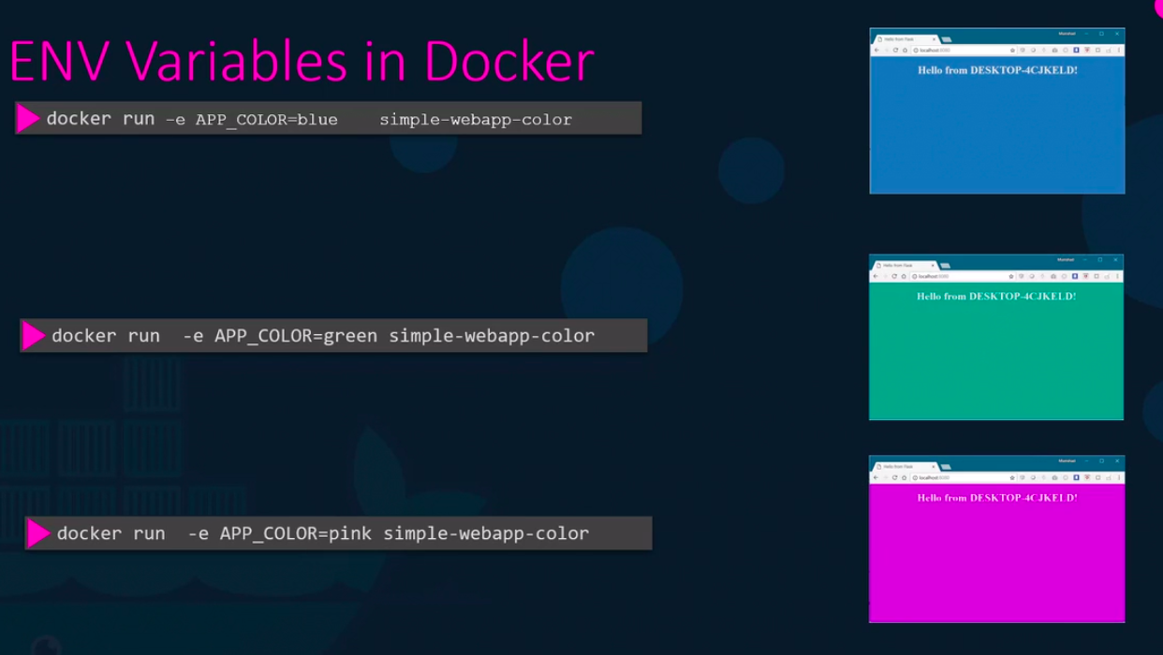

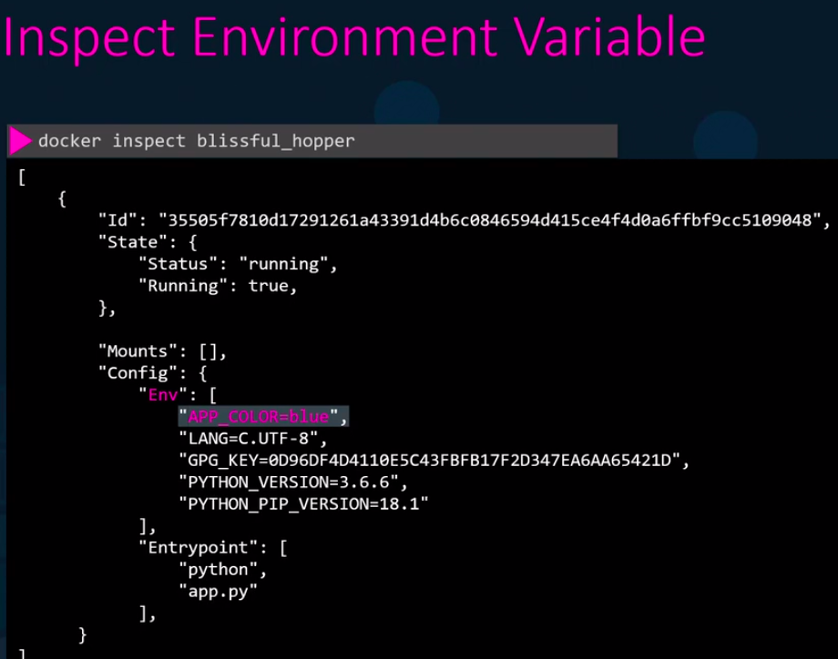

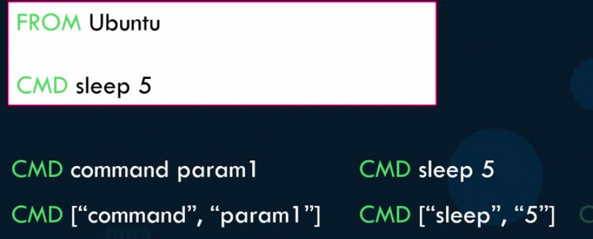

docker run ubuntu sleep 10



FROM Ubuntu

ENTRYPOINT [“sleep”]

CMD[“5”]

docker run ubuntu-container 15

docker run –entrypoint sleep2.0 ubuntu-container 10

**Docker compose :**

Compose is a tool for defining and running multi-container Docker applications. With Compose, you use a YAML file to configure your application’s services. Then, with a single command, you create and start all the services from your configuration.

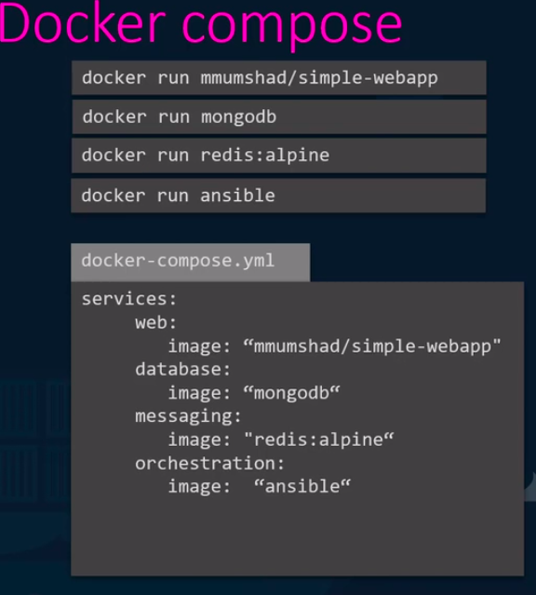



docker-compose up => to bring up the application stack.

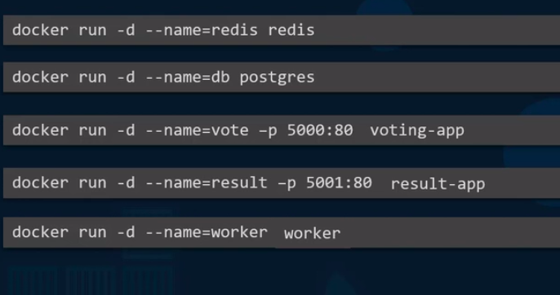

Gok 1 1 1 1 1

Cmrcet 2

Cmrec 1 1 1

Kmit 1 1 1 1

Geetam 1

Neil gogte inti 1